# **Ideas to website Update**

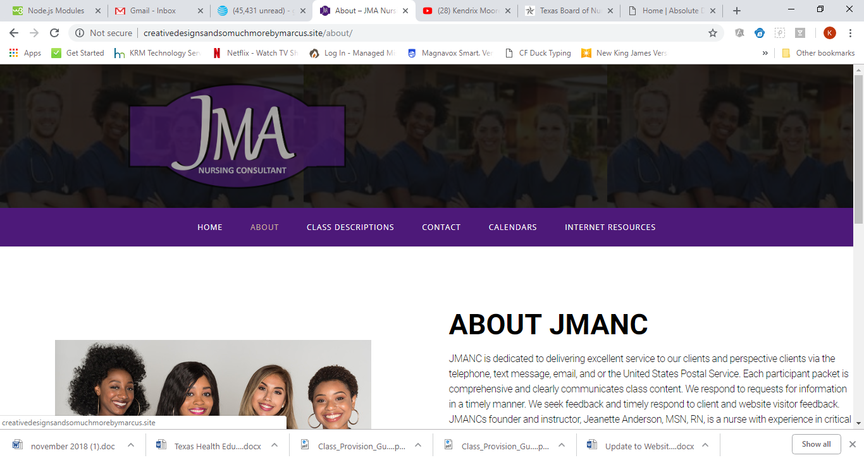

The logo JMA should be solid and background florescent, when you hover mouse over, JMA goes opaque/florescent and purple is solid.

Menu should have background image. Like below

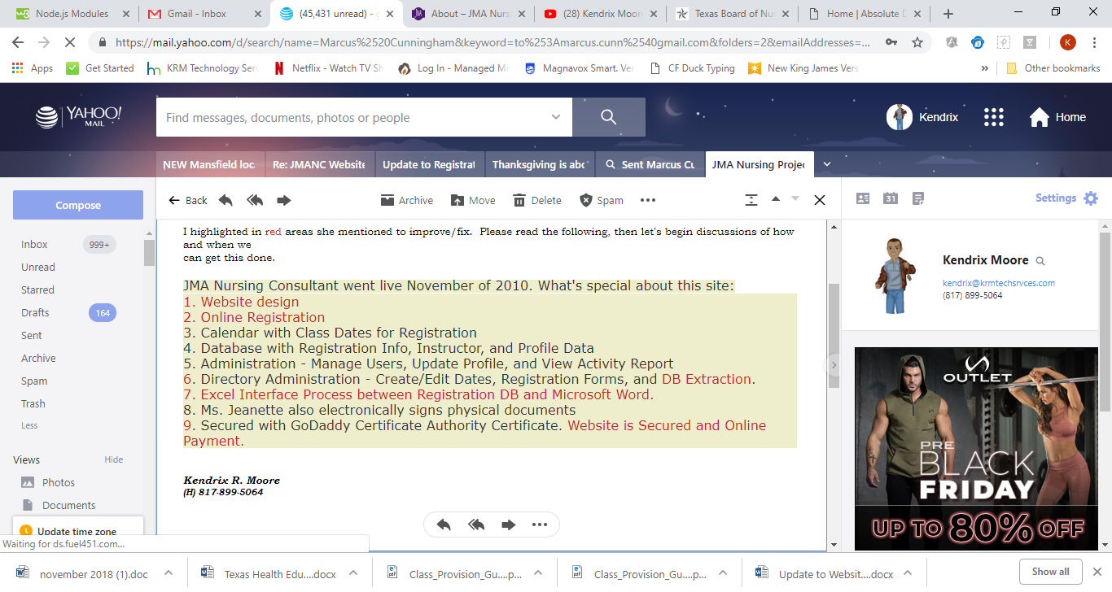

Current

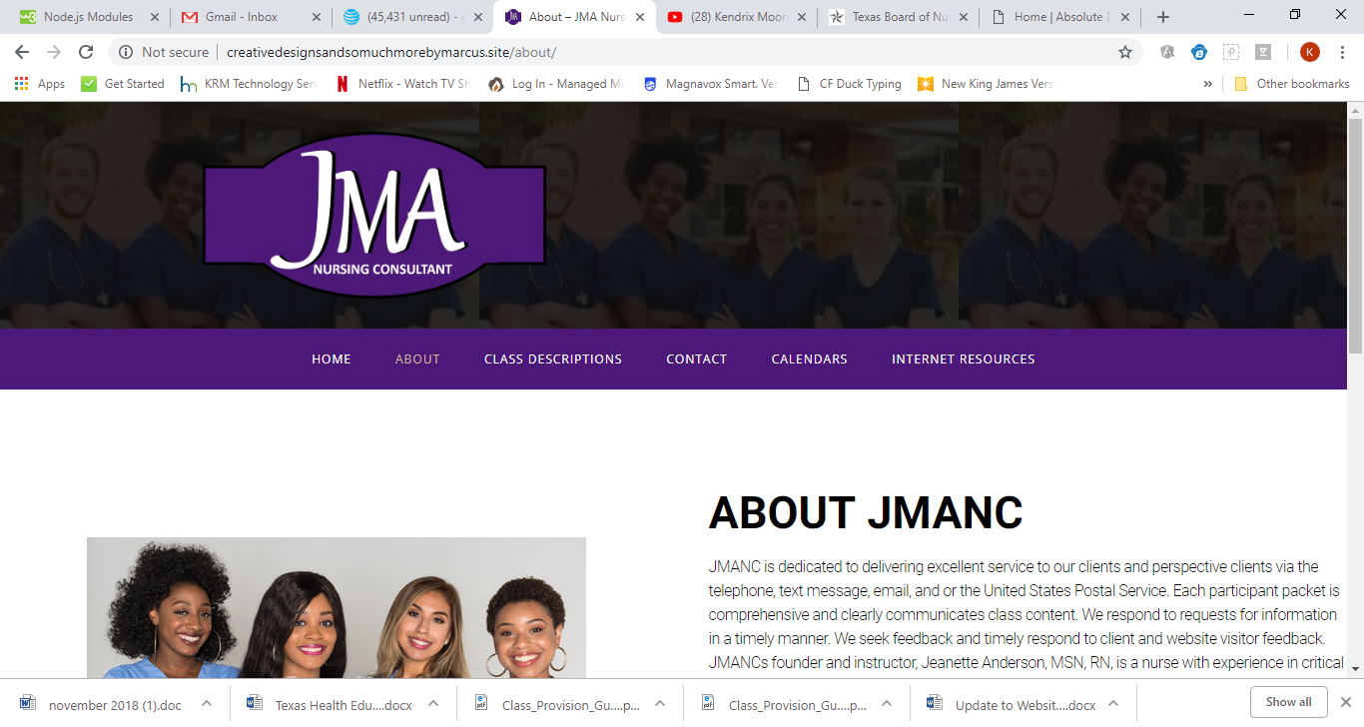

**Example of header softness**

**http://www.absolutedirectionnp.com/**